**History of US Banking and the challenges faced**

The United States banking system has a rich history that spans over two centuries. It has evolved significantly over time, influenced by various events and regulations. Here is a detailed overview of the US banking system, including graphs and statistical data:

**Early History (1791-1863)**

**First Bank of the United States (1791-1811)**

Authorized by Congress, the First Bank of the United States was a nationwide commercial bank that served as the bank for the federal government and operated as a regular commercial bank in competition with state banks. Its ownership was split between the federal government and private stockholders.

**Second Bank of the United States (1816-1836)**

Established after the War of 1812, the Second Bank of the United States was designed to stabilize the financial system and provide a central bank for the government. However, it was met with resistance from state banks and ultimately lost its charter in 1836.

**National Banking System (1863-1913)**

**National Banking Acts (1863 and 1864)**

The National Banking Acts of 1863 and 1864 established the United States National Banking System, providing incentives for creating a national currency supported by the holdings of banks of securities issued by the United States Treasury. This led to the creation of national banks, which were supervised by the Comptroller of the Currency.

**Federal Reserve System (1913-Present)**

**Federal Reserve System (1913)**

Founded in 1913 to implement monetary policy, the Federal Reserve System started operations in 1914, shortly after the outbreak of World War I. The Federal Reserve System is responsible for regulating and supervising banks, as well as maintaining the stability of the financial system.

**Post-World War II Developments (1945-Present)**

**Deposits in All Commercial Banks (1973-2024)**

Deposits have consistently increased over the years, with a significant surge during the 1980s and 1990s.

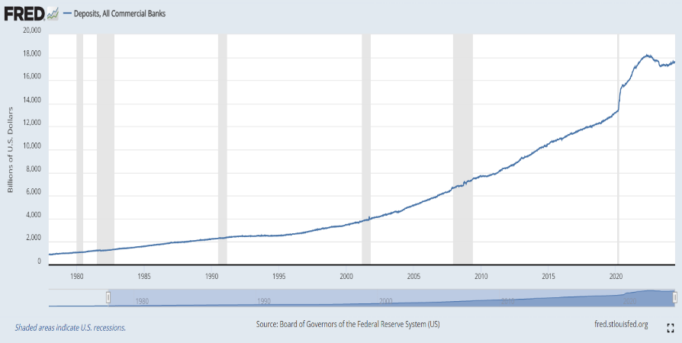

**Consolidated Financial Statistics for U.S. Commercial Banking Organizations:**

The total assets of U.S. commercial banking organizations have continued to grow, with a significant increase in the 2000s and 2010s.

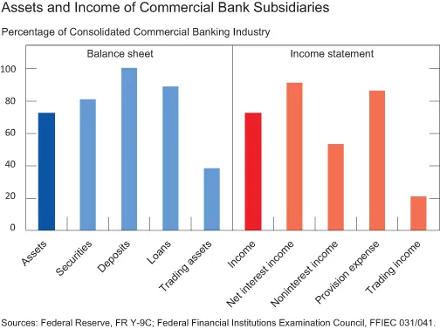

The US banking system has undergone significant changes over the years, influenced by various events and regulations. From the early days of the First Bank of the United States to the establishment of the Federal Reserve System, the system has evolved to become a robust and stable financial infrastructure. The graphs and statistical data provided here give a detailed overview of the growth and development of the US banking system.

**Challenges faced by the US banking system**

1. **Supervisory Inefficiencies**

**Lack of Urgency:** Regulators identified major problems but acted too slowly, allowing banks to continue operating despite significant risks.

**Structural Obstacles:** Cultural problems and structural obstacles have been embedded in the supervisory system for decades, making it difficult to address issues effectively.

1. **Risk Management**

**Liquidity Risk Management:** The collapse of Silicon Valley Bank and other financial institutions highlights the exposure of US banks to higher interest rates and the erosion of asset values.

**Commercial Real Estate Risk:** The sector is under significant stress due to factors such as remote work, elevated interest rates, and potential weakening demand, which could lead to additional bank failures.

1. **Regulatory Environment**

**Deregulatory Zeal:** The Federal Reserve and FDIC have been criticized for their deregulatory approach under former President Donald Trump's administration, which may have contributed to the crisis.

**Consensus Building:** The need for consensus between regional Fed banks and staff in Washington can slow down decision-making processes.

1. **Banking Culture**

**Pushback from Bank Management:** Bank managers may resist changes or confrontations with examiners, making it challenging for regulators to address issues effectively.

1. **Technological and Talent Challenges**

**Pace of Technology Change:** Finance leaders ranked the pace of technology change and digital disruption as a significant risk, highlighting the need for banks to adapt to changing conditions.

1. **Economic and Market Factors**

**High Inflation:** High inflation rates can lead to increased borrowing costs and reduced consumer spending, affecting bank performance.

**Interest Rate Hikes:** Rising interest rates can reduce the value of bank assets and increase the risk of bank failures.

**The solution to address the challenges**

1. **Supervisory Inefficiencies**

**Enhanced Regulatory Oversight:** Increase the frequency and thoroughness of regulatory examinations to ensure that banks are operating safely and soundly.

**Improved Communication:** Enhance communication between regulators and banks to address issues more effectively and quickly.

1. **Risk Management**

**Liquidity Risk Management:** Implement robust liquidity risk management strategies, including diversification of assets and liabilities, to mitigate the impact of interest rate changes.

**Commercial Real Estate Risk:** Implement stress tests to assess the potential impact of commercial real estate market fluctuations on bank solvency.

1. **Regulatory Environment**

**Deregulatory Zeal:** Implement a more balanced regulatory approach that balances the need for financial stability with the need for innovation and competition.

**Consensus Building:** Improve communication and collaboration between regional Fed banks and staff in Washington to facilitate more efficient decision-making.

1. **Banking Culture**

**Pushback from Bank Management:** Encourage a culture of transparency and cooperation within banks, where management is more open to addressing regulatory concerns and implementing necessary changes.

1. **Technological and Talent Challenges:\**

**Pace of Technology Change:** Invest in digital transformation initiatives to enhance the efficiency and effectiveness of banking operations.

**Talent Acquisition and Development:** Develop programs to attract and retain top talent in the banking industry, focusing on skills such as data analysis, cybersecurity, and digital transformation.

1. **Economic and Market Factors:**

**High Inflation:** Implement monetary policies that balance the need to control inflation with the need to support economic growth.

**Interest Rate Hikes:** Implement interest rate hikes gradually and predictably to minimize the impact on bank assets and the broader economy.

**Conclusion**

In conclusion, the US banking system has come a long way, evolving from a fragmented network to a more robust and federally regulated structure. However, significant challenges remain, including supervisory inefficiencies, risk management issues, a complex regulatory environment, and the need to adapt to technological advancements. By implementing stricter oversight, improved risk management practices, a more balanced regulatory approach, and a culture of transparency within banks, the US banking system can continue to adapt and ensure its stability in the face of future challenges. Additionally, investments in digital transformation and talent acquisition will be crucial for banks to thrive in a rapidly changing technological landscape. Finally, navigating economic and market factors like inflation and interest rates requires careful policy measures to minimize disruptions to the financial system. Through continuous adaptation and innovation, the US banking system can ensure a strong and stable financial future for the nation.